How To Install and Configure DNS Server on Linux Debian
A DNS server is used to resolve an IP address to a hostname and vice versa.
The most popular name server on Linux is BIND, stands for Berkley Internet Naming Daemon.
This tutorial explains how to install and configure Bind on Debian 8.4, using the diagram below as an example for installation.
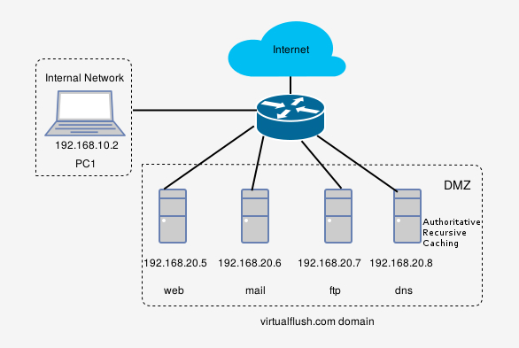

Step 1. Install BIND
BIND is available from the default Debian repositories, so we ca install the software using apt-get command-line tool.
dns# apt-get install bind9
Check to see if Bind is running:
dns# service bind9 status

Step 2. Create Zone Files on Master Server
Our DNS server will be authoritative for virtualflush.com domain. An authoritative name server can either be a primary/master or a secondary/slave server.
A slave DNS server will respond to requests if the primary server becomes unavailable and it is highly recommended to set up one ore more slave servers, but it is not the purpose of this tutorial because we have only one DNS server.
Bind configuration files are kept in a /etc/bind directory. Let’s change directory to /etc/bind and create a new folder where forward and reverse zone files will reside.
dns# cd /etc/bind
dns# mkdir master_zones
dns# cd master_zones
Create forward zone:
dns# nano db.virtualflush.com
The file should look like this:
; BIND data file for virtualflush.com
$TTL 86400
@ IN SOA dns.virtualflush.com. root.virtualflush.com. (
2016051001 ; Serial
3h ; Refresh after 3 hours
1h ; Retry after 1 hour
1w ; Expire after 1 week
3h ) ; Negative caching TTL of 3 hours
;
NS dns.virtualflush.com.
MX 10 mail.virtualflush.com.

web A 192.168.20.5
mail A 192.168.20.6
ftp A 192.168.20.7
dns A 192.168.20.8

www CNAME web
We have the forward zone configured and now we must to create the reverse zone file (reverse DNS is the opposite of forward DNS).
Note that you can manage reverse DNS for a subnet only if your Internet Service Provider has been delegated authority to your nameservers, otherwise you must contact the support department of your ISP.
In the reverse zone file we will define PTR records for reverse DNS lookups.
dns# nano db.192.168.20
The file should look like this:
; BIND reverse data file for 20.168.192.in-addr.arpa
$TTL 86400
@ IN SOA dns.virtualflush.com. root.virtualflush.com. (
2016051001 ; Serial
3h ; Refresh after 3 hours
1h ; Retry after 1 hour
1w ; Expire after 1 week
3h ) ; Negative caching TTL of 3 hours
;
NS dns.virtualflush.com.

5 PTR web.virtualflush.com.
6 PTR mail.virtualflush.com.
7 PTR ftp.virtualflush.com.
8 PTR dns.virtualflush.com.
Insert both zone file names into named.conf.local file:
dns# nano /etc/bind/named.conf.local

zone "virtualflush.com" {
type master;
file "/etc/bind/master_zones/db.virtualflush.com";
};

zone "20.168.192.in-addr.arpa" {
type master;
file "/etc/bind/master_zones/db.192.168.20";
};

Step 3. Edit Options File
We will configure this server to act as a caching DNS server and to performs recursive queries from our “Internal Network” clients – 192.168.10.0/24.
A caching DNS server performs recursive queries and stores the answer in its cache for a specific period (TTL value from zone records).
Just edit the named.conf.options file to look like this:
dns# nano /etc/bind/named.conf.options

options {
directory "/var/cache/bind";
dnssec-validation auto;

auth-nxdomain no; # conform to RFC1035
listen-on-v6 { any; };

recursion yes;
allow-recursion { 192.168.10.0/24; };
};
Note:If you want to forward requests to other DNS server, you can configure your server as a forwarding DNS server.
A forwarding DNS server is like a caching server but it does not performs recursive queries itself. Instead, it forwards all requests to other resolving server and then caches the results.
You can easily set up a forwarding DNS by adding the forwarders directive inside named.conf.local file.
The configuration file should look like this:
options {
directory "/var/cache/bind";
dnssec-validation auto;

auth-nxdomain no; # conform to RFC1035
listen-on-v6 { any; };

recursion yes;
allow-recursion { 192.168.10.0/24; };

forwarders {
//Google’s public DNS servers
8.8.8.8;
8.8.4.4;
};
};

Step 4. Test Bind Configuration Files
Check for errors in the configuration files by running the following command:
dns# named-checkconf
If there are errors found in configuration file, they will be displayed on screen, otherwise the above command will not display anything.
Now restart Bind service:
dns# service bind9 restart

Step 5. Test DNS Resolution
Test forward lookup with the dig command:
PC1# dig web.virtualflush.com @192.168.20.8 +short
192.168.20.5
PC1# dig mx virtualflush.com @192.168.20.8 +short
10 mail.virtualflush.com.
Test reverse lookup:
PC1# dig -x 192.168.20.5 @192.168.20.8 +short
web.virtualflush.com.
Finally, we need to configure client machine to use the DNS sever. On PC1, edit /etc/resolv.conf file and add a nameserver line like this:
PC1# cat /etc/resolv.conf

nameserver 192.168.20.8

